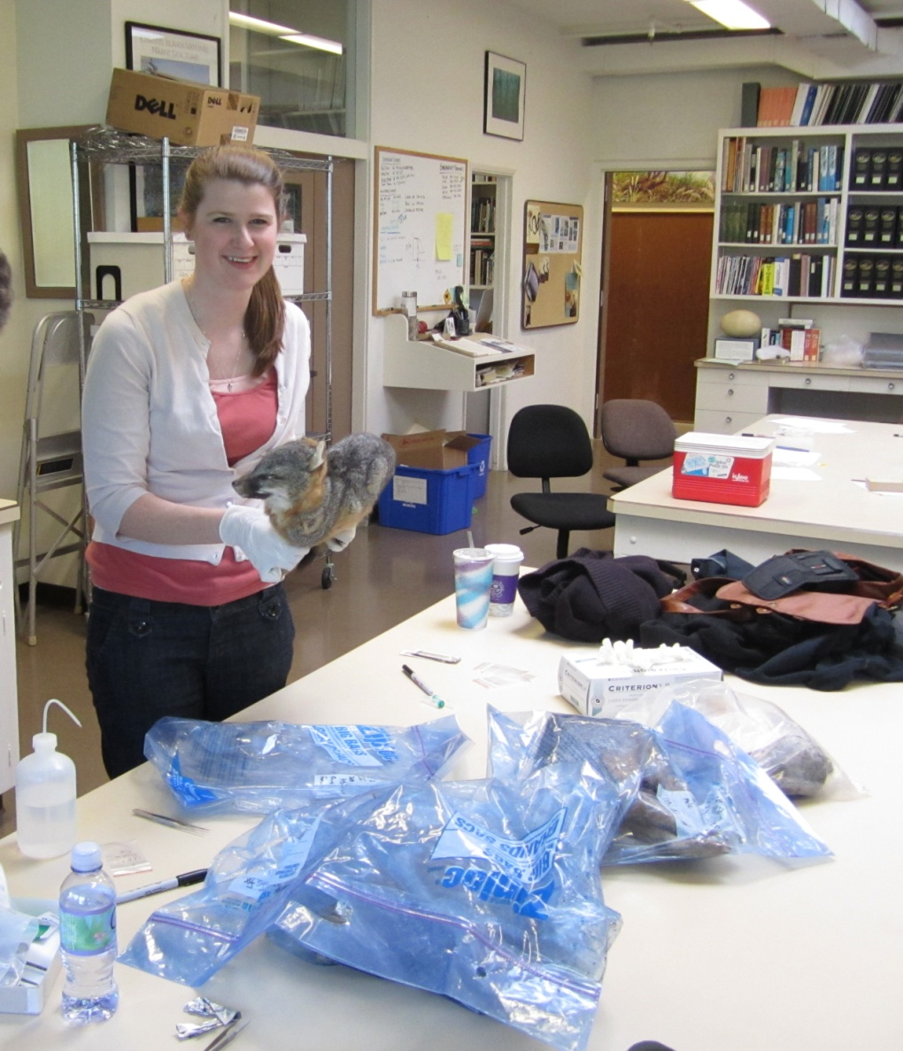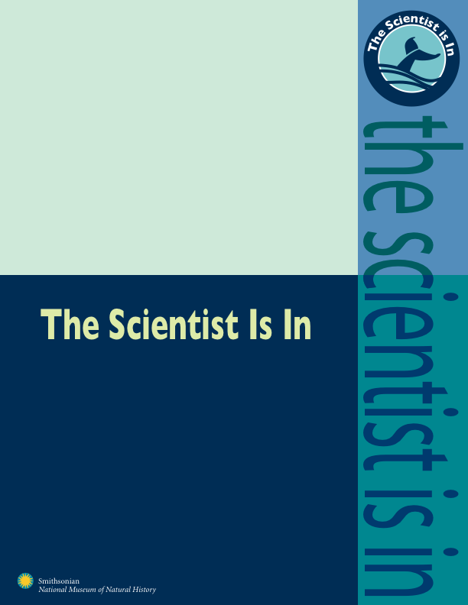

Courtney Hofman

Pre-doctoral Fellow, NMNH and Smithsonian Conservation Biology Institute

Courtney Hofman is a Ph.D. candidate in Anthropology at the University of Maryland and a Pre-doctoral Fellow at the National Museum of Natural History and the Smithsonian Conservation Biology Institute. Hofman's research focuses on developing genomic technologies to answer questions regarding human-environmental interactions through time. This “archaeogenomic” approach integrates archaeology with state of the art high-throughput DNA sequencing technology to analyze genome-wide genetic variation from ancient archaeological samples. Her current project examines how ancient people influenced island ecosystems through the introduction of foxes, mice, and possibly other mammals to the California Channel Islands. Understanding human/wildlife interactions and their influence on changing environments over the past several millennia helps inform decisions to protect, preserve, and restore biodiversity in the future.